**PrepSTEP: Preparing to take the TSIA**

1. Go to the “**Library Media Services**” tab on the RPHS homepage.

To get there: **fortbendisd.com /Schools / Ridge Point High School**



1. Under “**Most Popular RPHS Links”,** click the **PrepSTEP** link:

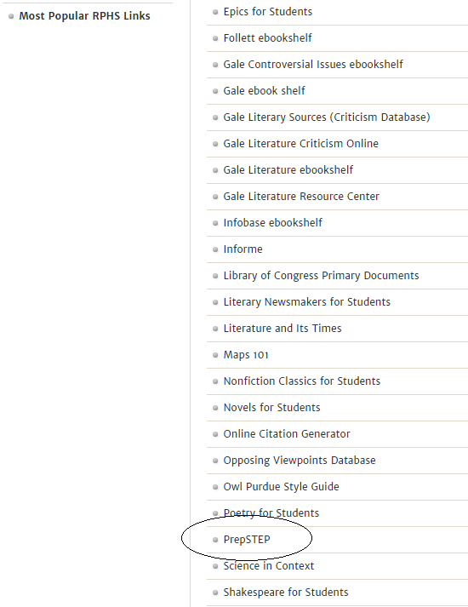

3. Log in or Register if a first time user.

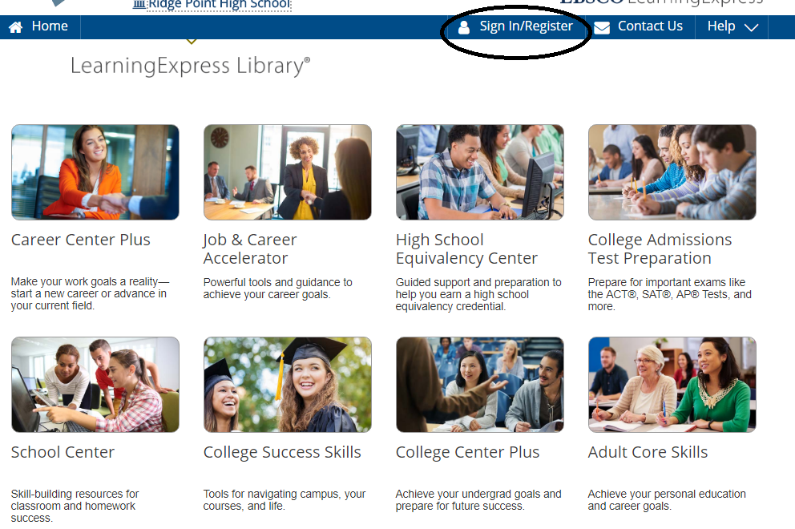

First time users: **REGISTER** using your school email and set your password.

Returning Users: This will be the **Login** each time you access PrepSTEP.

1. To locate TSIA practice tests, select the **High School** **Students** and select **Practice for State Tests**.

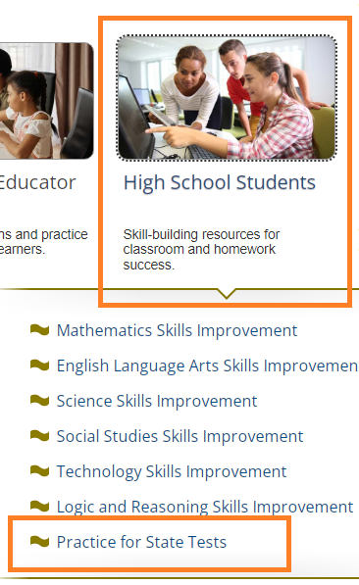

1. Select **TSIA Practice Tests**.

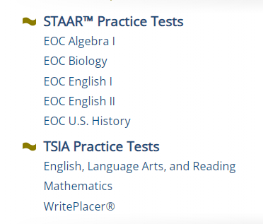

5. Scan the QR code to jump to the link if using a camera enabled device.



If prompted, select Fort Bend ISD from the pulldown menu.

Password: **3duc*t3**